**上海代表队在第65届英特尔国际科学与工程大奖赛（Intel ISEF）上获得大奖，载誉归来！**

**Shanghai Students excelled in 65th Intel ISEF with Grand Awards**

2014年5月16 日，第65届英特尔国际科学与工程大奖赛在美国加利福利亚州洛杉矶市洛杉矶会议中心圆满闭幕。本次大奖赛历时6天，吸引了来自全球70多个国家和地区的 1800余名青年科学家参与。其中包括24名中国大陆（21个项目）、12名香港（6个项目）和6名澳门地区（3个项目）的青少年科学家，项目内容涵盖工程、能源、生物化学、环境等多个领域。

On May 16th, 2014, the 65th Intel ISEF ended successfully in Los Angeles Convention Center in Los Angeles, California, the United States. The 6-day fair attracted more than 1800 young scientists from over 70 countries and regions all around the globe. Among the participants there were 24 from mainland China (21 projects), 12 from Hong Kong (6 projects) as well as 6 from Macau (3 projects), whose projects ranged from engineering, energy, bio-chemistry to environment.

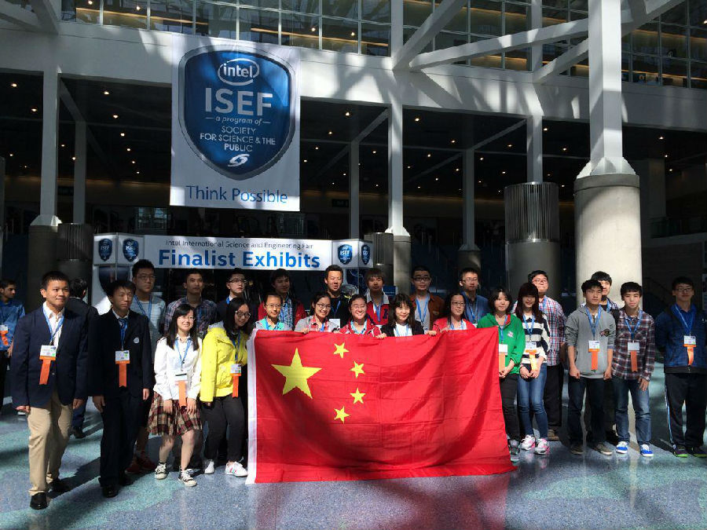

图为中国参加Intel ISEF全体选手

The figure shows all the Chinese participants of Intel ISEF

在本次大赛上，共有5名中国大陆学生凭借5个创新项目，获得共计7个奖项，其中上海代表队大获全胜，载誉而归！2013级中学生英才计划上海交通大学培育学员、上海青少年科学社高级会员、上海交通大学附属中学嘉定分校姚悦同学的项目《用光色叠加实现三进制运算的新方法及其数学证明》获得Intel ISEF计算机学科一等奖、计算机学科特等奖、欧盟青年科学家奖！另一位2012、2013级上海青少年科学社会员、上海中学的陈嘉延同学凭借其《无人四旋翼机载超声波立体探障及救灾路径规划研究》获得Intel ISEF工程类四等奖！姚悦同学2013-2014年在上海青少年科学社和上海交通大学接受了为期一年的培育，是继2001年上海青少年科学社会员朱元晨所获计算机学科特别奖后又一个得此殊荣的学生。

In the fair, 5 students from mainland China won 7 awards with 5 innovative projects. Among all the prize-winners, students from Shanghai werespecially honored for its fabulous performance. As a student cultivated by Shanghai Jiao Tong University in 2013 Middle School Student Talent Plan, a senior member of Shanghai Science Association for Young Talents （SSAYT）, Yue YAO from High School Affiliated to Shanghai Jiao Tong University(Jia Ding) won first prize in computer science, special award in computer science and European Union Young Scientist Award with his project<用光色叠加实现三进制运算的新方法及其数学证明%请找到作者准确的英语论文题目%>. While another member of Shanghai Science Association for Young Talents （SSAYT）, Jiayan CHEN from Shanghai Middle School also won the fourth prize in engineering with the project<%请找到作者准确的英语论文题目%>.

Yue YAO took a year’s training in Shanghai Science Association for Young Talents （SSAYT） and Shanghai Jiao Tong University during 2013-2014. He was another student who won the special award in computer science, after the winning of Shanghai Science Association for Young Talents （SSAYT） member Yuanchen ZHU in 2001.

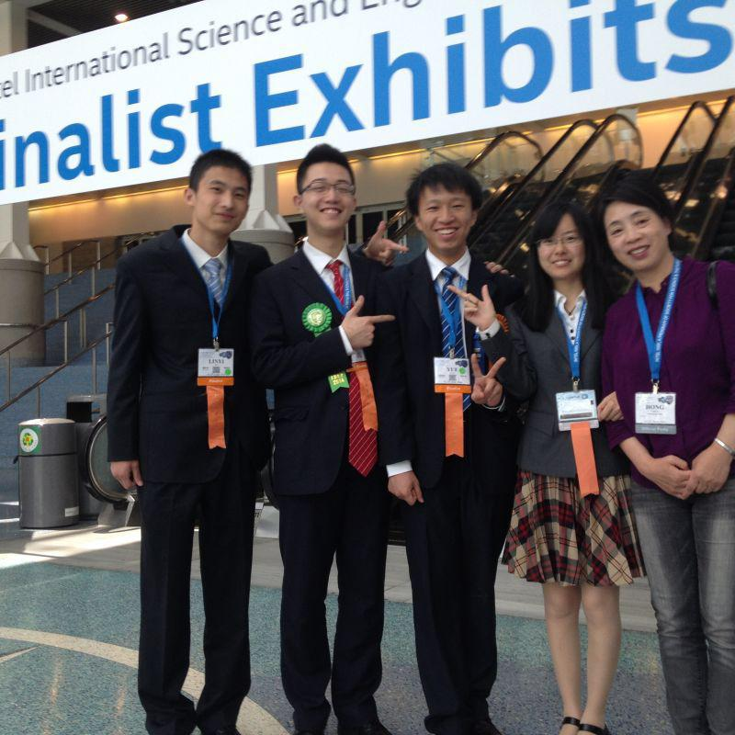

图为上海代表队四名选手及领队老师（左起七宝中学金林毅、上海中学陈嘉延、交大附中嘉定分校姚悦、华师大二附中娄澜青青、上海科学教育中心主任陈红）

The figure shows the 4 competitors from Shanghai as well as their teachers.

(from left: Linyi JIN from Qibao Middle School, Jiayan CHEN from Shanghai Middle School, Yue YAO from High School Affiliated to Shanghai Jiao Tong University(Jia Ding), Lanqingqing LOU from No.2 High School of ECNU, Hong CHEN from Shanghai Science Education Center)

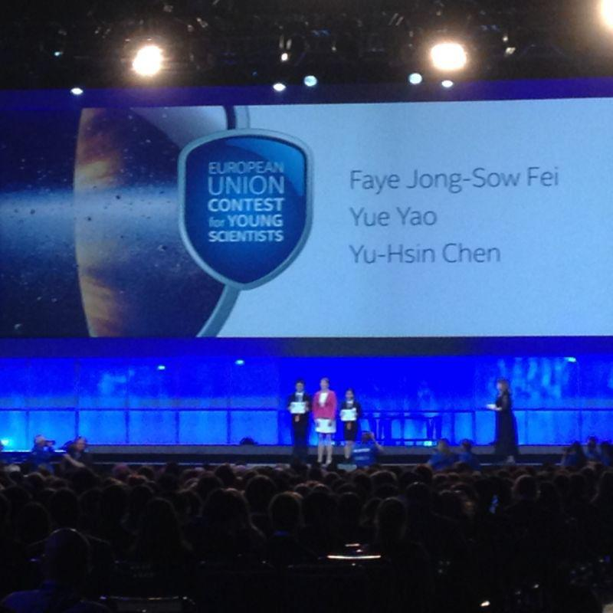

图为上海青少年科学社高级会员姚悦同学上台领取大奖

The figure shows the senior member of Shanghai Science Association for Young Talents （SSAYT）Yue YAO was awarded the prize.

被誉为全球青少年科学竞赛的“世界杯”的“英特尔国际科学与工程大奖赛”（Intel ISEF）每年吸引来自全球各地最有潜力的学生创业家、创新者和科学家共同参与。2014年英特尔国际科学与工程大奖赛由英特尔公司和英特尔基金会联合赞助，数十家公司、学术机构、政府和科学机构提供了总额超过了400万美元的奖金支持。决赛选手每年从全世界数百项联席赛事中脱颖而出，在美国接受超过1200名各学科领域专家评委的现场评审。

Honored as the ‘world cup’ in the global scientific competition field, Intel ISEF attracts student entrepreneurs, innovators and scientists with the most potential ability every year. In 2014, it was funded by the Intel Company and the Intel Foundation, and more than 4,000,000 dollars were provided by companies, academic foundations, government and research institutions as bonus. Those who were involved in the final list were among the best of hundreds of associated competitions in the world, and were judged face-to-face by more than 1200 experts in all fields in America.

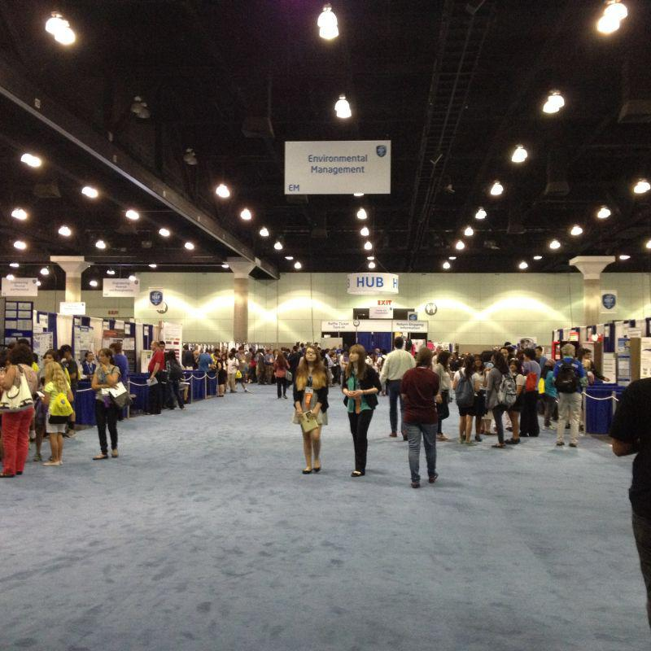图为第65届Intel ISEF会场

The figure shows the conference hall of the 65th Intel ISEF

　自2000年开始，中国科学技术协会在英特尔公司的赞助下，组织中国学生参加在每年在美国举行的英特尔国际科学与工程大奖赛。迄今为止，已有373名中国学生的230个项目入选Intel ISEF，并赢得了242个奖项，其中包括 2004 年上海学生朱元晨获得的Intel ISEF顶级奖项“英特尔基金会青年科学家奖”。中国区ISEF参赛选手均是从“全国青少年创新科技大赛”、“明天小小科学家”、“中学生英才计划”等国内顶尖赛事与项目中脱颖而出优秀学生代表，他们的科研项目体现了中国青少年日益提升的创新精神。

Since 2000, China Association for Science and Technology has gathered Chinese students to attend the Intel ISEF held in the U.S. every year under the foundation of Intel Company. So far, there has been 373 Chinese students, 230 projects that attend the Intel ISEF, and has won 242 awards, including the top prize won by Yuanchen ZHU from Shanghai in 2004, Intel Foundation Young Scientist Awards. All the ISEF participants in China are outstanding student representatives with excellent performances in some top scientific competitions in China, such as ‘CHINA ADOLESCENTS SCIENCE and TECHNOLOGY INNOVATION CONTEST’, ‘CONTEST FOR THE FUTURE SCIENTISTS’, ‘Middle School Student Talent Plan’. Their projects reveal the improvement of creative spirit of the Chinese youth.